Table of Content

National Sales Catalogue 2023

[shop on line] 2

<https://italian-military-representation-charity-bazaar.sumupstore.com/>



**ITALY**

**italiancharitybazaar@smd.difesa.it**

# Discover our shop online

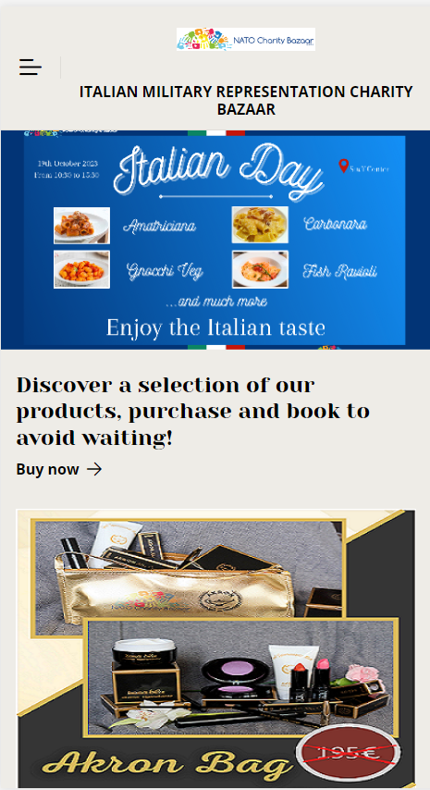cture]

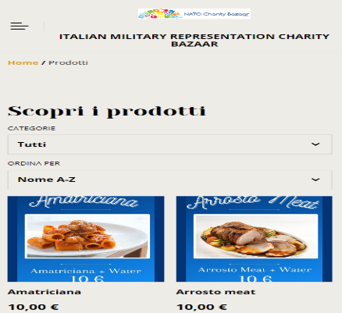

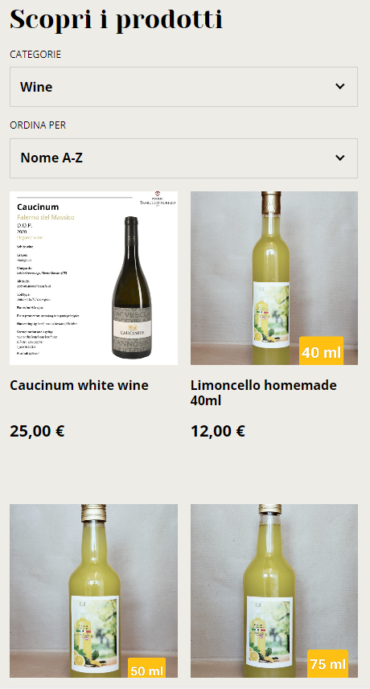 Picture]

**Delivery – Pick up**

ITA MilRep L.2.6

Luigi SANNINO

# https://italian-military-representation-charity-bazaar.sumupstore.com/