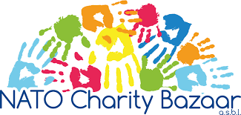
TOMBOLA 2022
The Tombola is similar to a lottery. Tickets typically cost 2.5 EUR, and anyone can buy any amount of tickets, but only some tickets will win prizes. In 2021, 11.000 tickets were sold, raising over 27.000 EUR for the NATO Charity Bazaar (NCB).
The prizes are offered by Nations, with every Nation offering at least two prizes of at least 100 EUR value each. There are no specific criteria as to what kind of prizes Nations can offer, but you should offer something of at least 100 EUR value. The NCB Team will compile a catalogue of the prizes, which will be available on-line and in hard copy as well, to facilitate in-person ticket sales. You can find the 2021 catalogue here.
The tickets are physical, on paper, with a serial number. They will be printed and provided by the NCB Team, and sold by the Nations and the NCB Team. Each ticket has two parts, with the serial number printed on both; buyers provide their name and contact details, and get a tab with the serial number, while the main ticket with their contact details stays with the selling team, for processing and to participate in the final drawing.
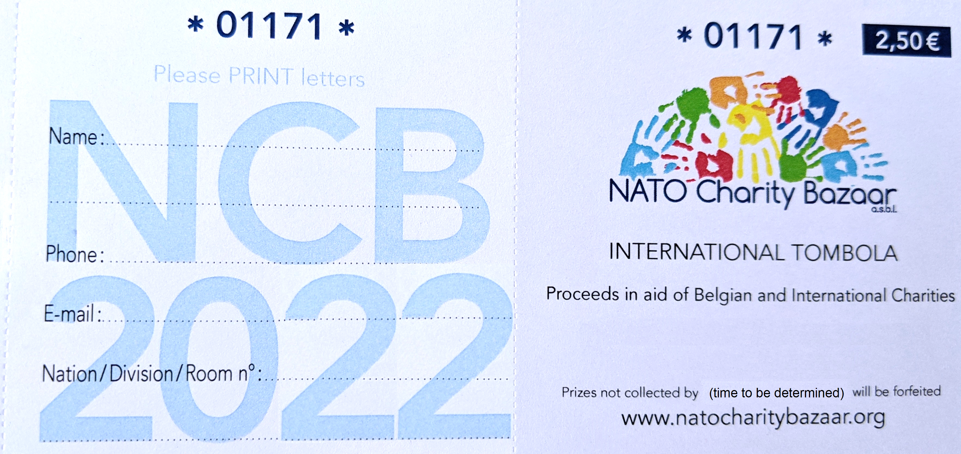NCB Tombola ticket example
Each Nation should let the NCB Team know how many tickets they need this year, corresponding to how many you think you can sell, approximately; this number is usually based on how many tickets you requested and sold the year before. You will soon receive a relevant request and a data sheet to fill in regarding your requested number of tickets this year, and you will have time until September to provide your request. If you have any doubts, please contact the Tombola Coordinator at the tombola@natocharitybazaar.org email address, and they can provide you more information regarding your Nation’s previous requests.
The winning tickets will be drawn from a pool containing all tickets sold, in a transparent and random manner, during the Charity Bazaar, at an open event organised by the NCB Team. At the event, each winning ticket will be randomly assigned one prize offered by a Nation. The NCB Team will notify the winners and will distribute the prizes in due process.
Approximate timeline:
- Nations provide ticket no. request – by 1 September
- Nations provide prize list – 2x prizes, min. 100 EUR each, with short description and images – by 1 November
- NCB distributes tickets to Nations – September
- [ If in-person sales are possible, the NCB will coordinate with Nations to book time slots in the Public Area of the HQ – September ]
- NCB Team compiles Prize Catalogue – continuous
- Ticket Sales by Nations, as well as the NCB Team – September-November
- Drawing Winning Tickets – on Bazaar Sunday, November
- NCB Team distributes prizes – December/as soon as possible
- NCB Team provides summary account of Tombola process at General Assembly Meeting – date to be determined

