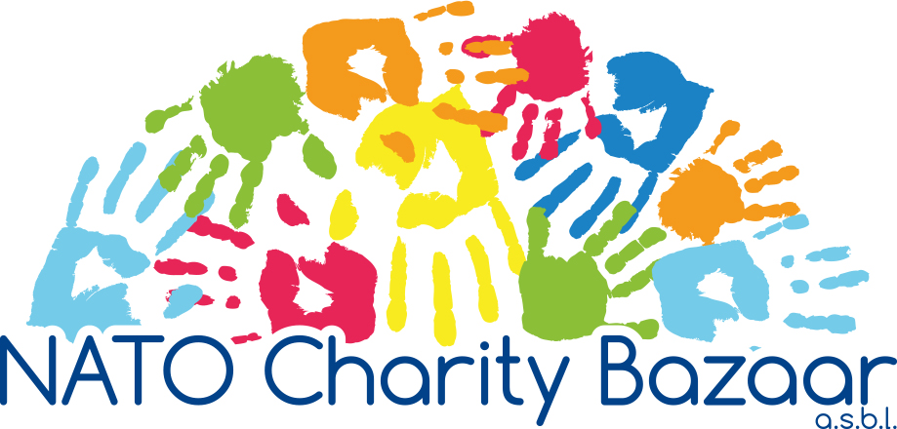

2021 Financial Accounting Form
All countries contributing to
NATO Charity Bazaar ASBL

Nation’s name :
Person making bank transfer :
Phone number : | E-mail :
NATIONAL CONTRIBUTION
Tombola Ticket Sales :
Small Change for a Big Change :
Delegation Sales :
Total Amount Bank Transfer:

- All NATO Charity Bazaar financial contributions should be by bank transfer to
NATO Charity Bazaar ASBL Account:
Aion SA: IBAN BE69 6434 0149 2878 - BIC BMPBBEBB

- Include in the communication section of your transfer the message:
Funds 2021 NCB + “Nation’s Name.”

- Please send by e-mail to the NATO Charity Bazaar Treasurer a scanned copy of:
  - Completed 2021 Financial Accounting Form; and
  - Bank transfer transaction receipt.

If you have any questions regarding the Financial Accounting Form or the transfer of funds,
please contact the NCB Treasurer Serge Devynck by e-mail at treasurer@natocharitybazaar.org.

All electronic transfers must be completed by: Monday, 6 December 2021.

