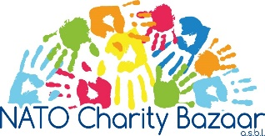

Agenda

General Assembly Meeting

Tuesday, 23 March 2021
9h15 – 11h15

President, Szabina Baros
- Opening words
- Roll-call and approval of minutes of General Assembly on 20 November 2020

Membership Coordinator, Olivia Ronayne Casimiro
- Welcome and Farewell to members

President, Szabina Baros
- Statutes update 2021
- Internal Regulations update 2021

Vice-President, Hanne Jørgensen
- Farewell to leaving Board members
- Introduction of Board member candidates
- Proposal for NCB Board 2021

Treasurer, Erin McCoy
- Financial report 2020
- Proposal for Budget 2021

President, Szabina Baros
- Voting

Coffee Break

Charity Coordinator, Stacey Gingrich
- Application Form and Guidelines for charities 2021

Vice-President, Hanne Jørgensen
- Lessons Learnt
- Upcoming events and Sales
- Any other Business & Closing

