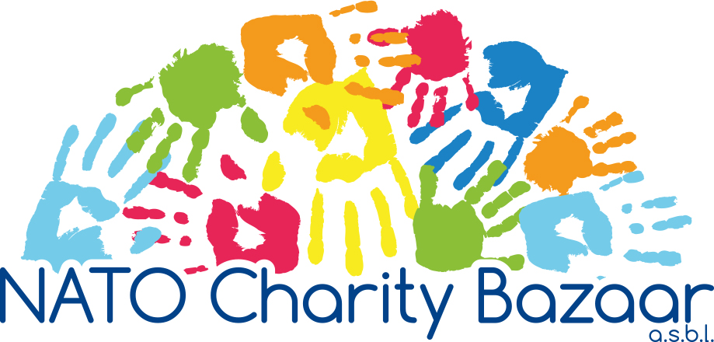

Date: 9 November 2020

Dear National Representative,

There are three important steps to transfer the funds you raised to the NATO Charity Bazaar’s account. Please keep in mind the following:
- All electronic transfers must be completed by Thursday, 3 December 2020.

#1 TRANSFER FUNDS via one of two ways:
- Bank transfer from your bank or
- Online account transfer

Aion SA bank details:
IBAN BE69 6434 0149 2878
BIC BMPBBEBB

IMPORTANT: Please include in the “Communication” section of your transfer the following message: "Contribution to the NCB in 2020 by … " (specify your Nation’s Name).

#2 COMPLETE FINANCIAL ACCOUNTING FORM specifying the total amount for each category: Tombola, Small Change, or Delegation Sales.

#3 SEND E-MAIL. As soon as possible after transferring the funds, please send an email to treasurer@natocharitybazaar.org with the following attached:
- Bank transfer transaction receipt; and
- Financial Accounting Form.

If you have any questions regarding the Financial Accounting Form or the transfer of money, do not hesitate to contact me by e-mail.
Thank you,
Erin McCoy
Treasurer (treasurer@natocharitybazaar.org)

PLEASE RESPECT THE DEADLINES

