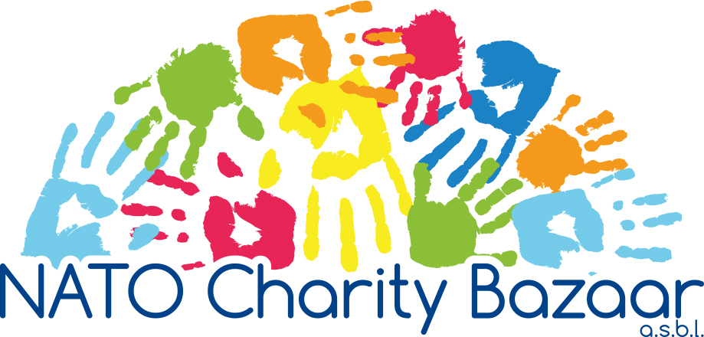

**Overview for voting process**

2020

*For Members Only*

# OVERVIEW

In order to familiarize you with the selection process of the charities in consideration for funding, we have put together this overview. The Charity Committee and the Board have spent many long hours reviewing every application to make sure each charity put before the members was qualified based on the voted upon selection criteria. First, the committee made sure the application arrived by the due date and was complete. Second, the committee reviewed each application based on the criteria stated in the application.

This year we received 14 Belgian applications, of which 11 were eligible. Three applications were rejected because they were not eligible this year based on the criteria (stated below). One additional application was denied in order to only have 35 applications on the ballot.

We received 45 international charity applications for funding. Many were rejected for the two-per-country rule and a few additional ones were not eligible based on the criteria stated in the application resulting in 25 eligible international applications.

## Factors taken into account when selecting charities for donation:

* The request should be for a specific project.
* The charity should be a non-profit organization officially registered (ASBL or VZW if located in Belgium) for at least one year.
* If benefiting organizations receive funds or authorization for funding for a project from the proceeds of a specific Bazaar, two complete calendar years for Belgian charities and three complete calendar years for international charities must pass from the date of that Bazaar, before the same organization may reapply to the NCB (for example, an international organization that has benefited from funds raised at the 2018 Bazaar can next apply in 2022).
* Application forms must be complete. All questions and requests for explanation should be addressed. If the question is not applicable to your organization, then write “Not Applicable.”
* To be considered a Belgian charity, the organization must exist in Belgium.
* We are most interested in funding projects that are:
  + Small specific projects – preferably ones that can be completed with the set amount within a year.
  + Projects that cover the widest spectrum of the community.
  + Projects which, when completed should have a long term impact and be

of benefit to as many people as possible.

* + Projects benefiting NATO countries, NATO PfP countries, and countries where NATO is currently engaged – but without excluding projects from other geographic locations.
* Staff salaries and administration costs as a general rule are not supported.
* The maximum amount donated is **10.000 euros.**

## After reviewing all the charities, the Committee has put together the list of eligible candidates presented in the two PRE-Briefing Books e-mailed to you recently.

The content of the PRE-Briefing Books was compiled from the information the charities provided on their funding application. For each charity you will find:

* The focus group - Target number - Summary of the project
* Cost of the entire project - Amount requested - Amount recommended by Charity Committee*

*Sometimes the amount recommended varies from the amount requested. If in reviewing the itemized budget of the project we saw that we could donate a smaller amount than requested and still fund an integral part of the project, we recommended the smaller amount.

**IMPORTANT: Please review the two PRE-Briefing Books before the 10 September General Assembly Meeting where we will be voting on the charities**.

# VOTING PROCESS

The 2020 charity vote will take place at the 10 **September** General Assembly Meeting.

Prior to coming to this meeting, you are requested to review both the Belgian and International Charities PRE-Briefing Books which have been sent out to all Members. We suggest you rank the charities prior to the meeting so you can more easily vote on the selected charities.

During the meeting, we will send you the link to the online voting portal – hosted by Survey Monkey. The National Representative will have 24 hours to complete the vote online. The Survey Monkey will be demonstrated during the GAM.

Each nation will be asked to rank the charities 1 through 25 for International charities and 1 through 10 for Belgian charities. Your first choice is #1 and your last choice is #10 (Belgium) or #25 (International).

Voting will close at 12h00 on 11 September. **Only online votes will be accepted, and only 1 vote per country is allowed.** We will explain briefly during the meeting how to fill out the voting form online and answer any questions you may have.

Survey Monkey will automatically calculate the rank score based on the responses each country has given. The charity with the highest rank score has the highest priority for funding.

In the event of a tie based on the above system, the charity with the most 1’s will get priority. If the number of 1’s is the same, the number with the most 2’s will get priority, and so on.

Once the voting process for all Belgian and International charities is completed, two (2) Board members will review the results in the analysis section of Survey Monkey. If a country is listed twice, we will contact the individuals who completed the surveys to determine which vote to keep and which vote to delete. Members can request the presence of one (1) witness during this review. Since this is an online survey, the results can be sent to an email address for verification.

After the meeting, the results will be exported to an Excel spreadsheet, printed, and stored in an envelope for at least two (2) years. Only the Management Board (the President, the Vice-President and the Treasurer) will have access to the physical results and the Charity team will have access to the online results which is password protected.

# The final result of the vote will be announced at the next General Assembly meeting.

# On behalf of the Board of the NATO Charity Bazaar ASBL,

***Stacey Gingrich, Ildikó Incze, Ashley Roche, Karine de Koninck, Monica Fornari***

Charity Coordinators for Belgian and International applications

Email: [charity@natocharitybazaar.org](mailto:charity@natocharitybazaar.org)